EECE 340 Project Module 2 Report

Abdullatif Itani 202203750

Charbel Toumieh 202218744

2.1- Nyquist Rate:

The Nyquist sampling theorem states that to accurately capture and reproduce a continuous-time signal in a discrete-time domain, the signal must be sampled at a rate that is at least twice the maximum frequency it contains. In other words, the sampling rate must be greater than or equal to twice the highest frequency component of the signal, also known as the Nyquist Rate, to prevent aliasing and ensure perfect signal reconstruction.

In the case of a signal with a maximum frequency of f0, the Nyquist Rate for perfect signal reconstruction is given by fN = 2f0 = 2 Hz for this problem. This means that the signal must be sampled at a rate of at least 2f0 samples per second to accurately represent the original signal in the discrete-time domain. Any sampling rate less than the Nyquist Rate can lead to aliasing, where high-frequency components of the signal are misrepresented as lower-frequency components in the sampled signal, leading to distortion and inaccuracies.

2.2- Sampling:

This code aims to demonstrate the effects of undersampling and oversampling a continuous-time signal with a given sampling rate. First we load the variable t and the associated data xt. The Nyquist Rate is then defined as 2 Hz.

To demonstrate the effects of undersampling and oversampling, the code calls the sample function with different sampling rates: 0.5fN for the undersampled signal and 2fN for the oversampled signal. The sample function takes the original time and signal data along with the desired sampling rate as inputs.

Afterwards, two subplots are generated to visualize the effects of undersampling and oversampling. The first subplot shows the undersampled signal at 0.5fN, where the sampling rate is lower than the Nyquist rate, resulting in aliasing. The undersampled signal appears to have a lower frequency than the original signal, and some high-frequency components are lost. The second subplot shows the oversampled signal at 2fN, where the sampling rate is higher than the Nyquist rate. Oversampling does not cause any loss of signal information but increases the computational time.

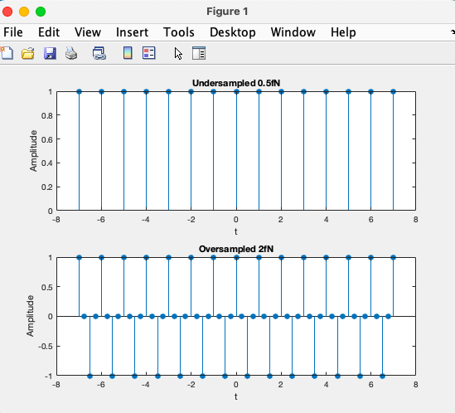

2.3- Reconstruction:

This code aims to demonstrate how to reconstruct signals that have been sampled at different rates by using the sinc method. The process involves two main steps: first, reconstructing the signal at the desired sampling rates using the reconstruct function, and second, plotting the reconstructed signals against the original time vector.

We use the reconstruct function to compute the reconstructed signal by taking the original time vector, t, the sampled signal, x_sample, and the sampling rate, fs, as inputs. The function first determines the number of samples to be reconstructed based on the length of the sampled signal and whether it is even or odd. It then computes the reconstructing interval, Ts, based on the sampling rate. The reconstructed signal is calculated using nested for loops that iterate through each time point in the original time vector and the samples to be reconstructed.

Afterward, we generate two subplots to display the reconstructed signals at 0.5fN and 2fN against the original time vector. The reconstructed signal at 0.5fN shows a distorted signal since the high-frequency components lost during undersampling have not been recovered. The reconstructed signal at 2fN displays an accurate representation of the original signal.

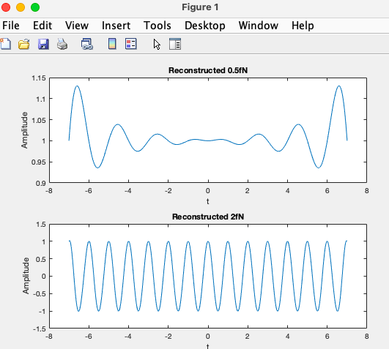

Which reconstruction is better? Explain.

As we can see the 2*fN is the better reconstruction because it accurately resembles the original signal since it is sampled at a higher frequency however the 0.5*fN figure did not accurately resemble the original signal so the oversampled is better since no data is lost and the undersampled is bad since a lot of the data was lost.

Can the reconstruction be perfect at any rate? If not, why not? (hint: the signal provided in Matlab is time-limited. What effects does it have on the bandwidth of the signal?)

Reconstruction cannot be perfect at any rate. This is because the original signal is time-limited, meaning it has a finite duration and bandwidth. As a result, the frequency content of the signal is also limited, and there will always be some loss of information when sampling and reconstructing the signal. This loss of information can result in artifacts and distortions in the reconstructed signal, particularly at higher frequencies. The amount of loss will depend on the sampling rate and the bandwidth of the signal.

How is it, then, that the reconstruction theorem “picks” the correct original signal and not any of the other signals?

Reconstruction theorem "picks" the right one by:

1-Following the Nyquist sampling rate to avoid aliasing. This limits the number of possible signals that can match the samples.

2-Using an ideal interpolation method (like sinc). This confines the frequency content and shape of the reconstructed signal.

3-Implicitly encoding information about the original signal in the samples. The samples contain clues that allow reconstructing the original signal.

4-Basing the reconstruction on an ideal model of sampling. This ensures the reconstructed signal matches what would result from ideally sampling the original signal.

5-Applying constraints like finite energy and duration. These limit the number of possible reconstructed signals, allowing the original signal to emerge.